Algebra I Common Assessment Review

- Which value of t gives the line passing through (-2,-1) and (t, -6) a slope of - $\frac{5}{4}$ ?

- A student launches a model rocket. The height of the rocket, h, in feet after t seconds is given by the function h = -16 t² + 16t + 4. Identify the range of this function.
a. All real numbers less than or equal to 8 b. All real numbers from 0 to 8
c. All real numbers between 0 and 20 d. All real numbers from 0 to 16

- The graph of the line y = 2x + 4 is shown below. What is the zero of a given line?
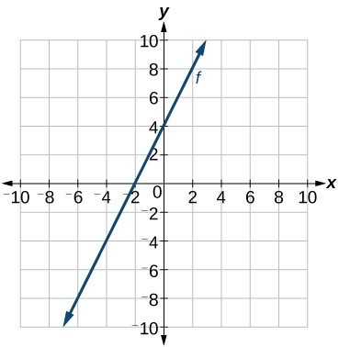

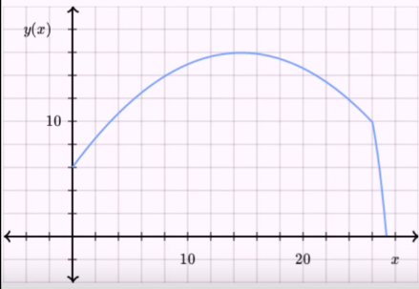
- Coach Agho is honing his deadly 3 point precision on the basketball court. For one of his shots, the height of the ball (in feet) as a function of horizontal distance (in feet), y(x), is plotted below. Coach Agho is standing at x= 0. What is the significance of the y intercept of this function? A. The ball is released from Coach Agho’s hands at a height of 6 feet
B. Coach Agho is shooting the ball from 26 ft away
C. The rim of the hoop is 10 ft. high
D. The maximum height the ball reaches is 16 ft

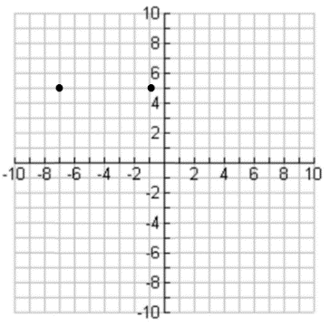
- Two points on the graph of a quadratic function are shown on the grid below.

What is the equation for the axis of symmetry of the graph of this function?
- X = -4
- Y = -4
- X = 4
- Y = 4

- Which of the following best describes the graph?
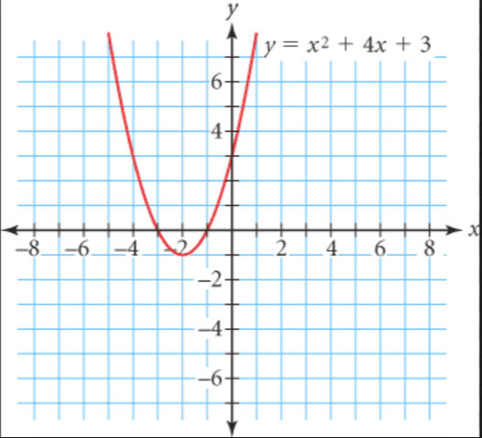

- The x-intercepts are -3 and -1, the y-intercept is 4 and the axis of symmetry is x = -1
- The x-intercepts are -3 and -1, the y-intercept is 3 and the axis of symmetry is x = -2
- The x-intercepts are 1 and 3, the y-intercept is 3 and the axis of symmetry is x = -1
- The x-intercepts are 1 and 3, the y-intercept is 4 and the axis of symmetry is x = -2

- Determine which relation is a function.
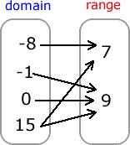
- C. (3,5), (-2,2), (3, 3), (-5,-8), (0,0)

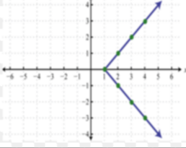
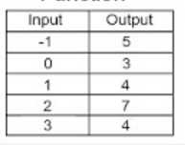
- D

- If h(p) = $\frac{3}{5}$p + 4, what is the value of h(-20)?
Record your answer and fill in the bubbles on your answer document.

- What is the range of the function graphed on the grid?
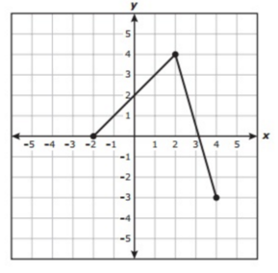
- x = -2, 2, 4

- -3 ≤ y ≤ 4

- -2 ≤ x ≤ 4

- y = -3, 0, 4

- Which of the following best describes the graph?
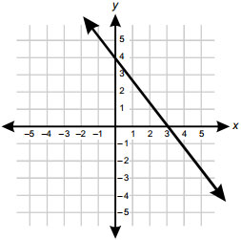

- The x- intercept is 4; the y-intercept is 3; the graph is positive for x < 3, the graph is negative for x > 3
- The x- intercept is 3; the y-intercept is 4; the graph is positive for x < 3, the graph is negative for x > 3
- The x- intercept is 3; the y-intercept is 4; the graph is negative for x < 3, the graph is positive for x > 3
- The x- intercept is 4; the y-intercept is 3; the graph is negative for x < 3, the graph is positive for x > 3

- What is the range of f(x) = $x^{2}$ – 6
- All real numbers
- All real numbers greater than or equal to 0
- All real numbers greater than or equal to -6
- All real numbers greater than or equal to -5

- What is the range of the relation graphed below?
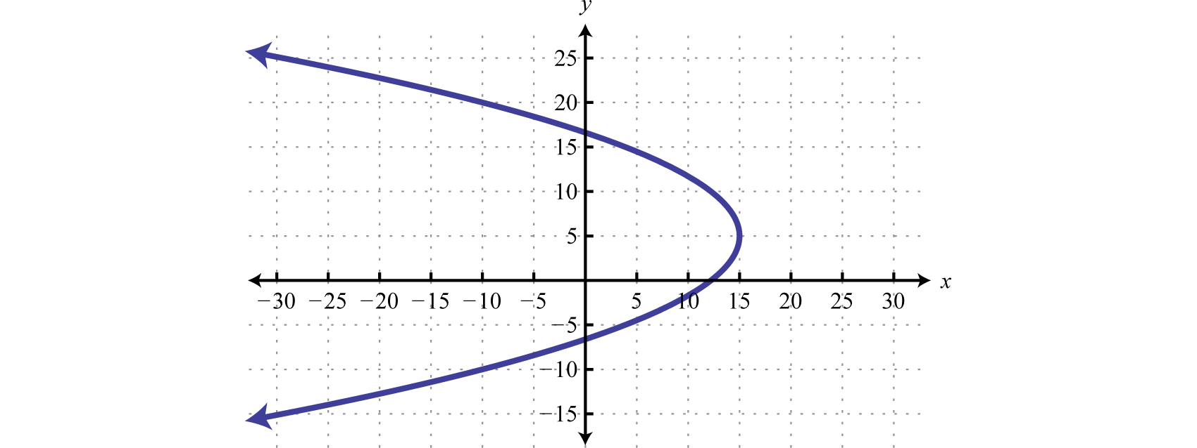

- The graph of the quadratic function j is shown in the grid.
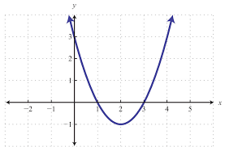

What is a solution to j(x) = 0?
- 2
- 4
- 1
- -3

- What is the x-intercept of the following table?
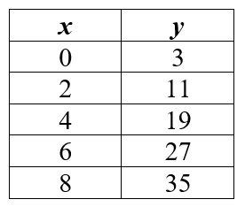

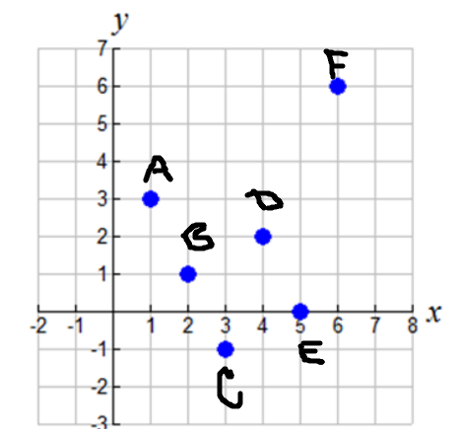
- State the domain of the relation.

- 3, 1, -1, 2, 0, 6
- 1, 3, 4, 5, 6, 6
- 1, 2, 3, 4, 5, 6
- Not here

