Download TI Connect CE Software - Choose the first option TI Connect CE Software for Windows (EXE)
https://education.ti.com/en/us/software/details/en/CA9C74CAD02440A69FDC7189D7E1B6C2/swticonnectcesoftware
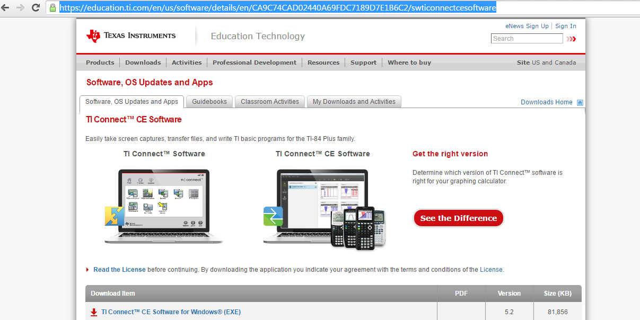
Continue as guest
Run Program (it will take a few seconds to download)
Click “Yes” to make changes to your device
Continue with the SetUp Wizard -Click Next (twice) then Install
Wait for program to install
Select “Install” Yes, I would like the program to install
Click “Finish” – Now the program should be installed on your computer. Now you can proceed to download the TI- 84 wabbit emulator

Download TI-84 Plus Operating System
https://education.ti.com/en/us/software/details/en/B7DADA7FD4AA40CE9D7911B004B8C460/ti84plusoperatingsystem
“Accept” End User License Agreement – You may have to take a quiz, so the system know you are not a robot. After the quiz, click “Accept.”
Now you can Download the TI-84 Plus Operating System
Run the Program

To Download Calculator:
Go to : https://wabbit.codeplex.com/
Click Download
Create a ROM image using open source software
Select “TI-84 Plus SE”
Select second option Browse for OS files on my computer
From the Downloads menu select TI84Plus_OS255 – Open file
Save file
Click finish
The Wabbit Emulator should appear on the screen

For easy access for students
Go to wabbitemu File: Select “Pin to Start Menu”
Drag the icon from the program file to Desktop – This creates a shortcut on the desktop

